Access Control List Report
College of Science, Engineering, and Technology, Grand Canyon University
ITT-216: Enterprise Route & Switch
Instructor Tim Collins
Liela Pressley
4/23/2023
What are Access Control Lists?

Access control lists enable the protection of information and organization of traffic by providing a means of management by administrators to qualify or unqualify traffic for different portions of a directory or network device. Once the packet is assessed and considered illegitimate, it can be flagged down when trying to access another part of the network. Typically this is executed by a predetermined list of rules that specifies users/systems who have access or don’t have access to an object or resource. Often associated or confused with firewalls, access control lists provide the ability to assess the basic addresses/facts of a packet and compare it to basic standards of security. Unlike stateful firewalls, this is not the only function that access control lists provide. ACL not only provides the ability to filter traffic, but is used to filter routing updates, used to identify interesting traffic, or in Policy Based Routing (routing decisions)(Burts, 2019). To be specific, ACLs are considered stateless firewalls because they do not store information on the state of connection and filter packets based on information about the packet rather than inspecting its contents. As seen in Figure 1-A, the stateless ACL configuration is able to display the source and destination IP address, the service associated with the packet, what action it should take (deny/permit), and the time.
There are 2 main types of access control lists, file system ACLs which permit or deny access to files and directories, and networking ACLs which manage the access of traffic between switches and routers, and specific user permission inside a network. There are a wide variety of ACL applications and types, and two common methodologies closely related to file systems ACL include filter-based and non-filtered ACLs. Filter-based ACLs use a specified object filter in order to recognize and match specific objects with the access that appropriately applies. Non-filtered ACLs on the other hand, apply only to the directory entry that is holding it. (IBM Documentation, n.d. & Lutkevich, 2022).
Standard and extended IP ACLs and what each is used for
There are many different types of ACLs responsible for various protocols such as IPv4, IPv6, AppleTalk, and more. In IPv4 there are two simple types to be concerned with, Standard ACL and Extended ACL. Though both types have similar goals they vary in their scope, standard ACL checks the ACL source address and permits/denies the entire protocol. Extended ACL on the other hand, is more for a gatekeeper for an entire network. How? It checks the packet’s source and destination address and permits/denies only specific protocols or applications (Figure 2-A). For example, Extended ACL focuses on TCP and UDP ports (source and destination) as well as protocol type (learncisco.net, 2023).
ACLs should be placed where they can have the greatest impact on efficiency within the traffic flow of the network. This means standard ACLs are placed near the destination so that their limited trajectory will not hinder the flow of traffic, creating inefficiency. Whereas extended ACLs are placed near the source of the traffic flow (Cisco Networking Academy, n.d.).

Advantages and Disadvantages of each type
In addition to Standard and Extended ACLs, there are two other major types of ACLs, Dynamic, and Reflexive. Dynamic ACLs recreate in real-time when a user accesses an interface. If configured properly to enforce general access control policies of static and extended ACLs, dynamic ACLs allow for a more responsive network. Reflexive ACL allows for session filtering to be added to packet filtering within other ACLs. For instance, an interface is able to create a temporary ACL entry for specific packets during a session because a reflexive ACL rule was previously established that allowed certain packets associated with the session to enter. Because this type of ACL has a very specific function, it only appears when triggered and then is removed when the given session ends. But when configured it should be nested inside the Extended ACL and not applied directly to any sort of interface. It is important to note that creating ACLs that are misconfigured can equally be as devastating for a company’s network security.
Overall effect of ACL control on traffic
Access Control Lists provide networks with security, efficiency, and ease of management within the traffic flow. It is through ACLs that network administrators can ensure that the devices on a network are less likely to be infiltrated with untrustworthy packets from the internet. In Figure 3-A, the Network ACL is located between the actual subnet and router. The traffic travels from the internet through the router and is filtered by the ACL prior to interacting any further on the subnet. Through ACL filtering, administrators can enable least privilege and other user permission strategies among clients and users while also having different endpoint devices, routers, servers, etc administer filtering. ACL provides security but also aids in network traffic efficiency. How? Networking ACLs provide specific instructions to the switches and routers on the network on what type of traffic is allowed to interact with the different endpoints. This eliminates unnecessary and unwanted traffic congesting the network.

Illustrations
Figure 1-A (Firewall Policies, n.d.).
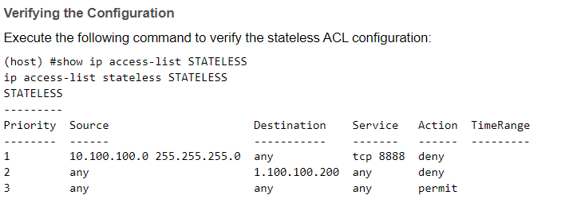

Figure 2-A (Cisco CCNA ACL Part III, 2000)
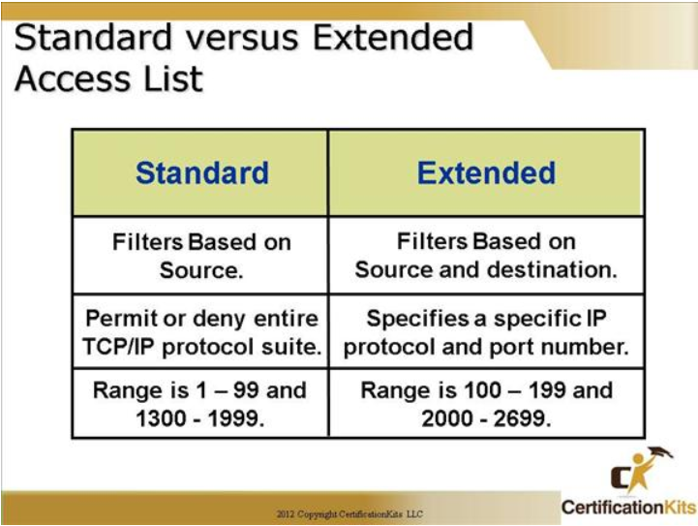
Figure 3-A
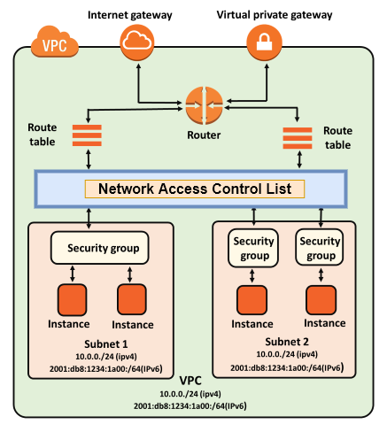

References
Burts, R. (2019, March 5). Difference between ACL and firewall. https://community.cisco.com/t5/switching/difference-between-acl-and-firewall/td-p/449204#:~:text=An%20access%20control%20list%20is,through%20and%20what%20to%20block.
Cisco CCNA ACL Part III. (2000, January 1). CertificationKits.com. https://www.certificationkits.com/cisco-certification/cisco-ccna-640-802-exam-certification-guide/cisco-ccna-acl-part-iii/
Cisco Networking Academy. (n.d.). Types of IPv4 ACLs (4.4) > ACL Concepts | Cisco Press. https://www.ciscopress.com/articles/article.asp?p=3089353&seqNum=7
earncisco.net. (2023, January 10). Types of ACL - Standard and Extended ACLs - learncisco.net. https://www.learncisco.net/courses/icnd-1/acls-and-nat/type-of-acls.html
Firewall Policies. (n.d.). https://www.arubanetworks.com/techdocs/ArubaOS_73_Web_Help/Content/mas_guides/roles_and_policies/Policies.htm#:~:text=Stateless%20Firewall%20Policy%20(Stateless%20ACL,for%20TCP%20and%20UDP%20traffic.
GeeksforGeeks. (2022). Access Lists ACL. GeeksforGeeks. https://www.geeksforgeeks.org/access-lists-acl/
GeeksforGeeks. (2021). Reflexive Access List. GeeksforGeeks. https://www.geeksforgeeks.org/reflexive-access-list/
IBM Documentation. (n.d.). https://www.ibm.com/docs/en/i/7.1?topic=security-access-control-lists
Jack Wang. (2012, July 16). Access Control List (ACL) Tutorial - Cisco CCNA Part 1 [Video]. YouTube. https://www.youtube.com/watch?v=B2Otbr9bDRY
Lutkevich, B. (2022). access control list (ACL). Networking. https://www.techtarget.com/searchnetworking/definition/access-control-list-ACL#:~:text=An%20access%20control%20list%20(ACL)%20is%20a%20list%20of%20rules,traffic%20can%20access%20the%20network.

